Hydraulic Guide Rail

Installation Manual

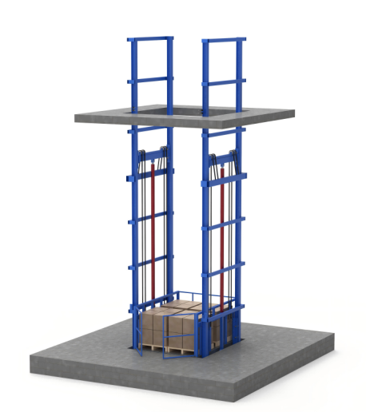

I. Manual Instructions
This manual systematically outlines the installation procedures, technical standards, and safety operating guidelines for hydraulic guide rail lift , applicable to guide rail installation tasks in industrial settings such as lifting equipment. Installation personnel must strictly adhere to the procedures outlined herein to ensure precise guide rail installation and guarantee the stability and safety of equipment operation.

II. Pre-Installation Preparation

(I) Study of Technical Documentation
- Read carefully the hydraulic system schematic diagram, pipeline connection diagram, and guide rail assembly installation manual to fully understand the system's operating principles, component structural features, and installation technical requirements.
- Review the installation detail list to confirm that the model and specifications of all components comply with the design requirements; inspect the operational status of each component to ensure the adjustment mechanism operates smoothly and the display device responds accurately. Any defective components identified should be replaced promptly; installation with faulty components is strictly prohibited.

(II) Preparation of Tools and Materials
- Tool category: wrenches, welding machines, cutting machines, levels, jacks, laser rangefinders, scaffolding, hoists, cranes, etc.
- Material category: Wear-resistant hydraulic oil, expansion bolts, U-shaped clamps, plate chains, lifting steel cables, connecting bolts, etc. (Refer to the shipping list)

(III) Safety Protection
- Installation personnel must wear personal protective equipment such as safety helmets, protective gloves, and goggles. It is strictly prohibited to work under the influence of alcohol or when fatigued.
- The work area shall be marked with clear warning signs; unauthorized personnel and obstacles must be removed. No one is permitted to stand beneath lifting operations to ensure a safe and controllable construction environment.
- The shaft opening must be properly sealed to prevent falls. A barrier or warning sign should be installed at the opening to alert personnel to the potential fall hazard.
- Test operation procedure: Unauthorized personnel are prohibited from entering the equipment room and shaft. Before commencing operations, ensure all safety circuits are functioning properly. Any work on electrical equipment must be performed only after the power supply is disconnected. Power disconnection must be carried out by qualified personnel, and a warning sign must be displayed on the power switch box during this period to alert personnel that the power switch must not be turned back on.

III. Installation Steps

1. Installation of the base seat

(1) Fixing the guide rail base seat
- On the pit floor, mark the centerline of the elevator car guide rail. Align the center of the car and the guide rail with this line, then adjust the levelness after placement; the error must not exceed 1/1000.
- In the absence of a pre-installed steel plate base, a steel plate with a thickness of ≥12 mm and specified dimensions may be placed beneath the guide rail and fixed to it via spot welding (pre-welded to the guide rail during manufacturing). The assembly is then secured to the ground using expansion bolts.
- The device can be installed either in the pit or on the ground. The figure below shows a pre-designed hydraulic guide rail freight elevator pit (pit dimensions are determined by the manufacturer).
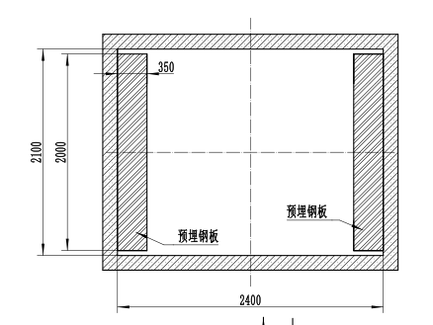
Pre-installed steel plate
Figure 1: Plan view of the guide rail freight elevator pit
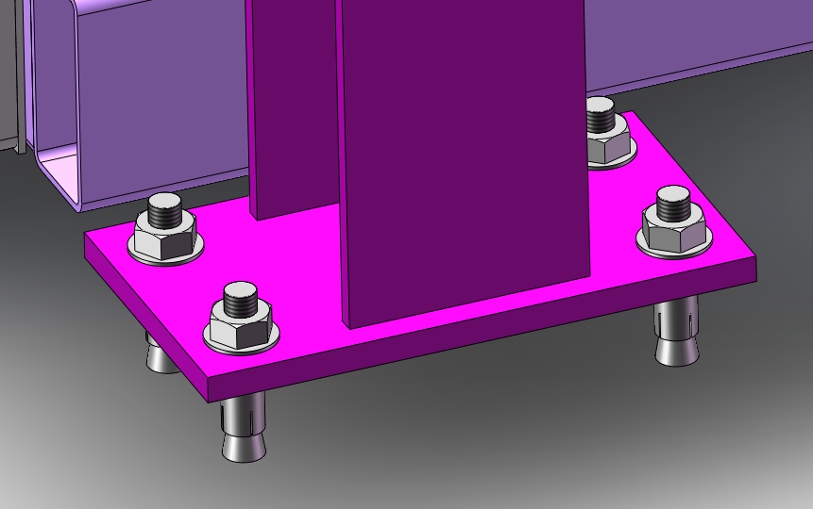
Figure 2 Schematic diagram of the expansion bolts connecting the guide rail freight elevator floor plate to the ground

2. Guide Rail Lifting and Installation

(I) Lifting Preparation
- A pulley should be securely installed at the central opening of the top floor slab for guide rail lifting. For floors above the 10th level, the use of a winch for mechanical lifting is recommended; for floors below the 10th level, nylon rope or steel wire rope may be employed for manual traction lifting. During the lifting process, dual hooks should be used to secure the guide rail connection plate to ensure balanced force distribution.
- Clean the dust from the surface of the guide rail tenon, ensuring it faces upward to prepare for subsequent guide rail assembly.

(II) Guide Rail Installation
- Ascend the guide rails to the predetermined position. First install the first layer of guide rails and make initial adjustments to their alignment. Then sequentially install the upper layers. During alignment, ensure the guide rail joints remain in a semi-tightened state. Use the suspension wire and guide rail straightening plate for adjustment; the verticality error must not exceed 1/1500. Once the guide rails are confirmed straightened, tighten the screws.
- The distance between the top end of the uppermost guide rail and the floor slab shall not exceed 100 mm; any excess portion must be cut and trimmed using a grinding saw. The use of gas welding for cutting is strictly prohibited to avoid compromising material properties.
- When connecting guide rails, the joint gap must comply with specified requirements. The tenons and grooves of adjacent guide rails must fit tightly to ensure a smooth and misalignment-free connection.
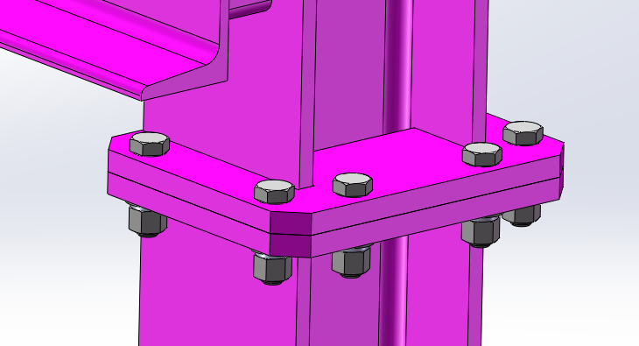
Figure 3 Schematic diagram of rail connections

3. Installation of the platform guide wheels

(I) Platform Positioning
Position the elevator car platform at the designated location, bringing it close to the guide rail as shown in the figure.
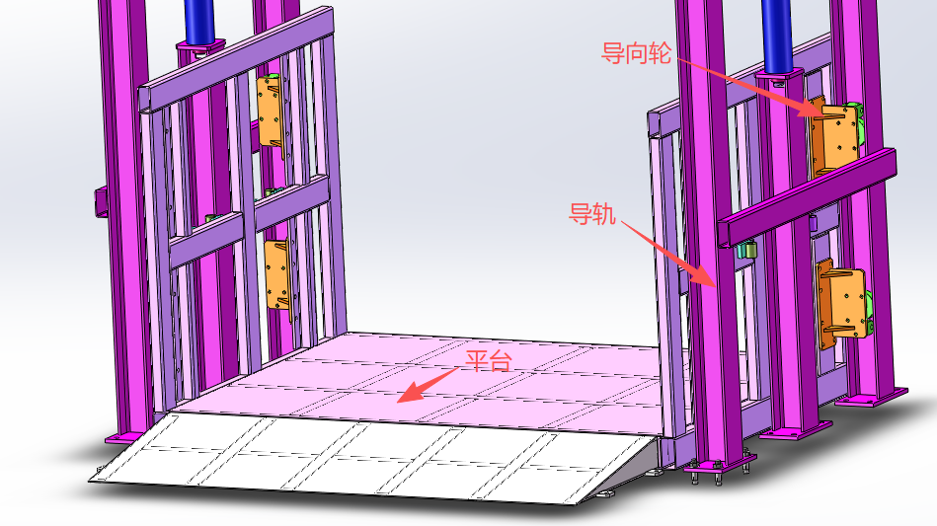
Guiding wheel
Guide rail
Platform
Figure 4 Schematic diagram of the guide rail and platform positions

(II) Fixed guide wheel assembly
- After positioning the platform, secure the guide wheel assembly to the platform's side lifting frame using bolts, ensuring the guide wheels fit precisely into the grooves of the H-shaped steel.
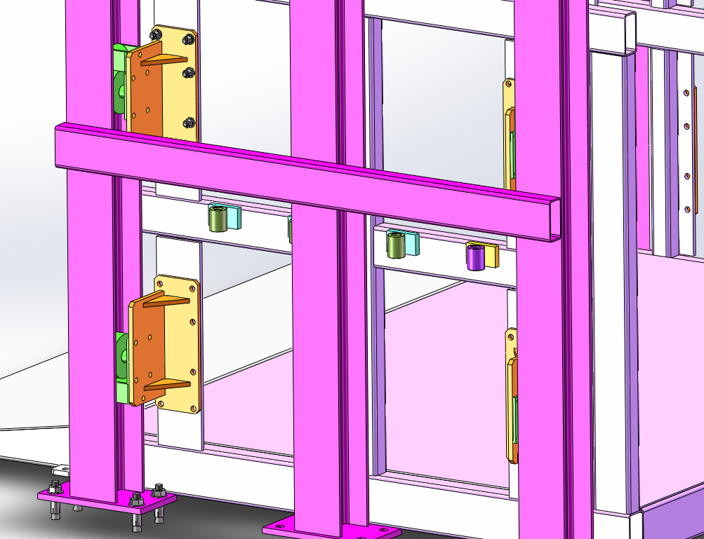
Figure 5 Schematic diagram of the installation position of the guide wheel assembly

4. Install the jacking frame
- Insert the jacking frame from the upper part of the guide rail into its groove and connect it to the top of the hydraulic cylinder.
- The lifting frame is equipped with chain pulleys and wire rope pulleys. The plate chain and wire rope are wound around the frame, with one end connected to the platform and the other end connected to the guide rail.
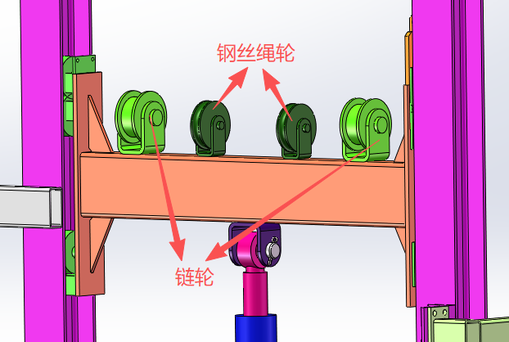
Steel wire rope pulley
Sprocket
Figure 6 Schematic diagram of the jacking frame position

5. Installation of intermediate connecting support
1. After completing the rail connection, install a connecting bracket at the midpoint to enhance the stability of the equipment. Secure the intermediate connecting bracket with bolts.
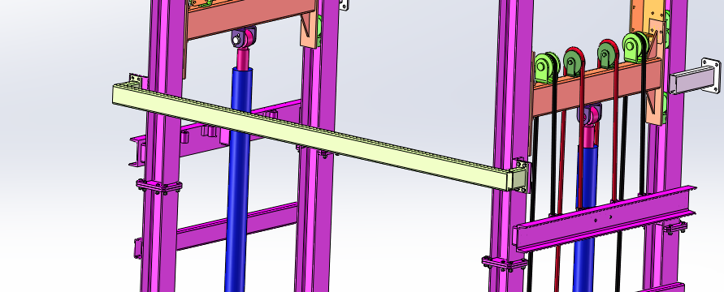
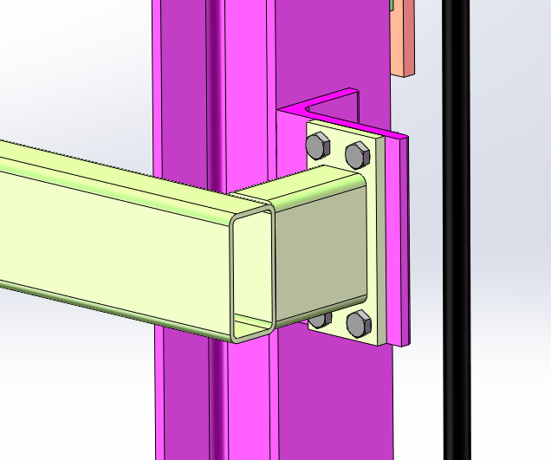
Figure 7: Schematic diagram of the fixed position of the intermediate connecting brace

6. Installation of the top connection bracket
1. A top connection bracket must be installed on the top of the guide rail to enhance equipment operational stability. Secure the bracket with bolts.
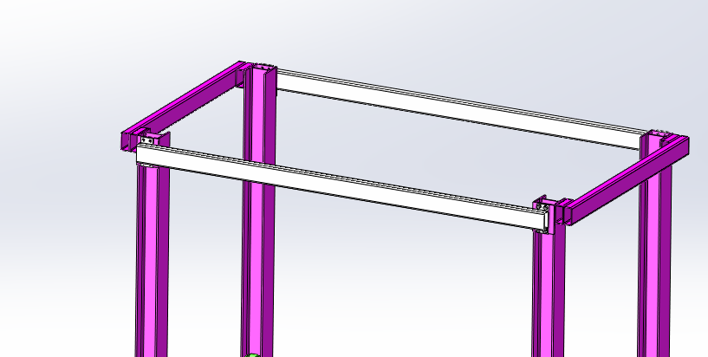
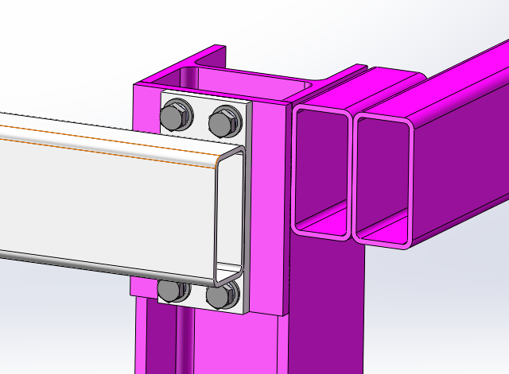
Figure 8 Schematic diagram of the fixed position of the top connecting bracket

- Due to potential measurement errors during on-site installation, the manufacturer provides several rectangular tubes and mounting plates, which customers can cut to the required length.
- Weld the mounting plate to the rectangular tube, position the tube at an appropriate location along the rail, and secure it to the vertical wall using expansion bolts. For steel structures, direct welding is applicable.
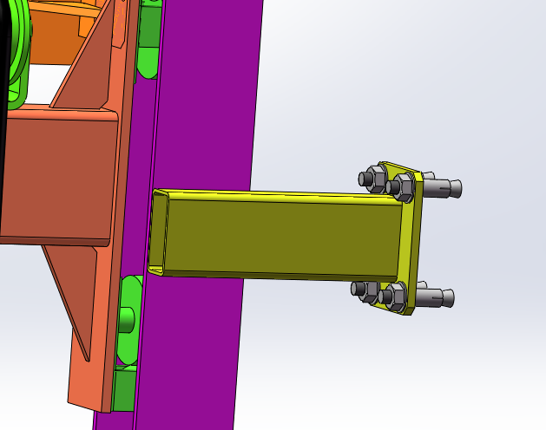
Figure 9 Schematic diagram of frame fixed installation

7. Installation of Hydraulic Cylinder

(1) Installation on the top of the hydraulic cylinder
- Connect the top of the hydraulic cylinder to the support lug of the lifting frame, using a pin and a cotter pin for positioning and connection.
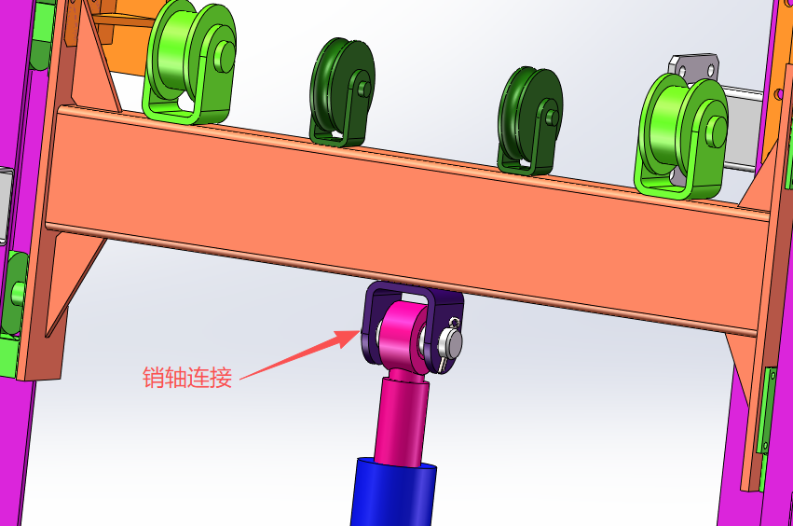
Shaft pin connection
Figure 10 Schematic diagram of the installation position at the top of the hydraulic cylinder

(II) Installation at the bottom of the hydraulic cylinder
- Mount the hydraulic cylinder on the guide rail frame mounting base and secure it with bolt pins. (Pre-installed when available before shipment.)
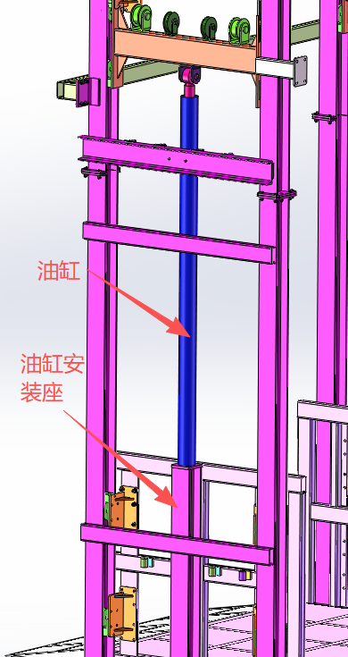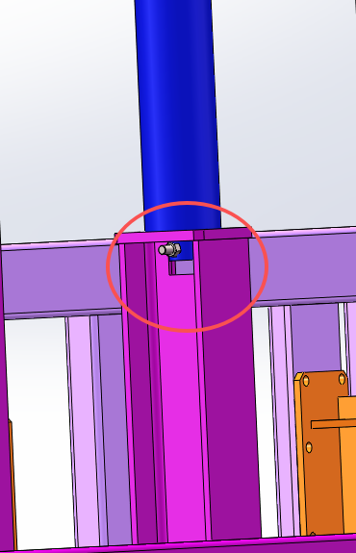
Cylinder mounting base
Cylinder
Figure 11 Schematic diagram of the installation position at the bottom of the hydraulic cylinder

8. Connection chain, steel wire rope
1. Secure the chain to the platform lifting frame and guide rails using chain connecting rods; fix the steel wire rope to the platform lifting frame and guide rails with lifting rings. The wire rope passes around the lifting frame, with one end connected to the platform and the other end connected to the guide rails.
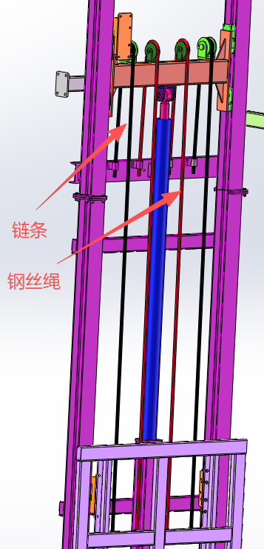
Steel wire rope
Chain
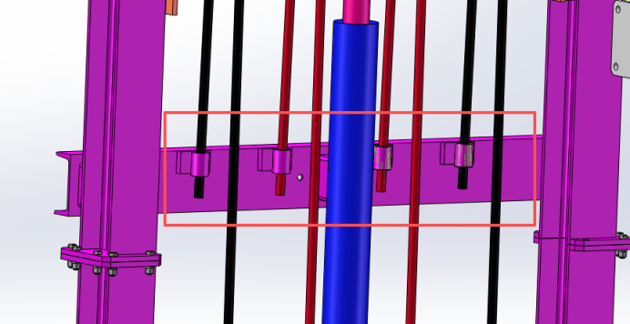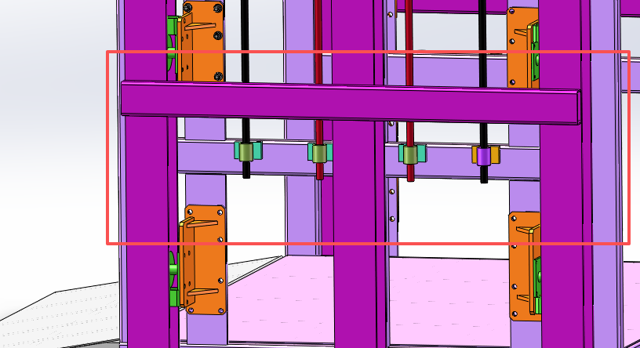
Figure 12 Schematic diagram of the fixation positions for the chain and steel wire rope

9. U-shaped clamp installation
Pass the U-shaped clamp through the pre-drilled hole in the guide rail and tighten it with a nut to secure the hydraulic cylinder firmly without any movement.

10. Hydraulic Oil Pipe Installation
First remove the plug from the oil inlet at the bottom of the cylinder. If an explosion-proof valve is present, install it first at the oil inlet. Then connect the hydraulic hoses in the order indicated by their markings.

11. Installation of hydraulic pump station
The weight of the pumping station (including the throttle valve) varies slightly depending on the tank model.
The pump station must be stored in a dry environment at a temperature between 5°C and 30°C. During installation, secure the pump station enclosure to the floor of the machine room using expansion bolts according to the shaft layout diagram. Both the motor and pump have undergone testing and calibration before leaving the factory; avoid arbitrary adjustments during installation. The motor and pump are assembled within the pump station.
The pumping station must be located as close as possible to the wellbore, with sufficient space to maintain a nearly constant indoor temperature.
Connect the hydraulic oil pipes according to their corresponding specifications. Prepare all required components before installation. The pump station has two oil pipe connection ports; note that the gasket should be positioned inward before tightening and securing the pipes to the hydraulic station. To fill the hydraulic oil tank, open the tank cover, add the oil, and then close the cover.

12. Wiring Method
After completing the mechanical installation, wiring and debugging are required. Connect the main power cable to the power supply of the distribution box according to the provided electrical wiring diagram. Install the control box near the equipment, ensuring sufficient space and maintaining a clean environment.

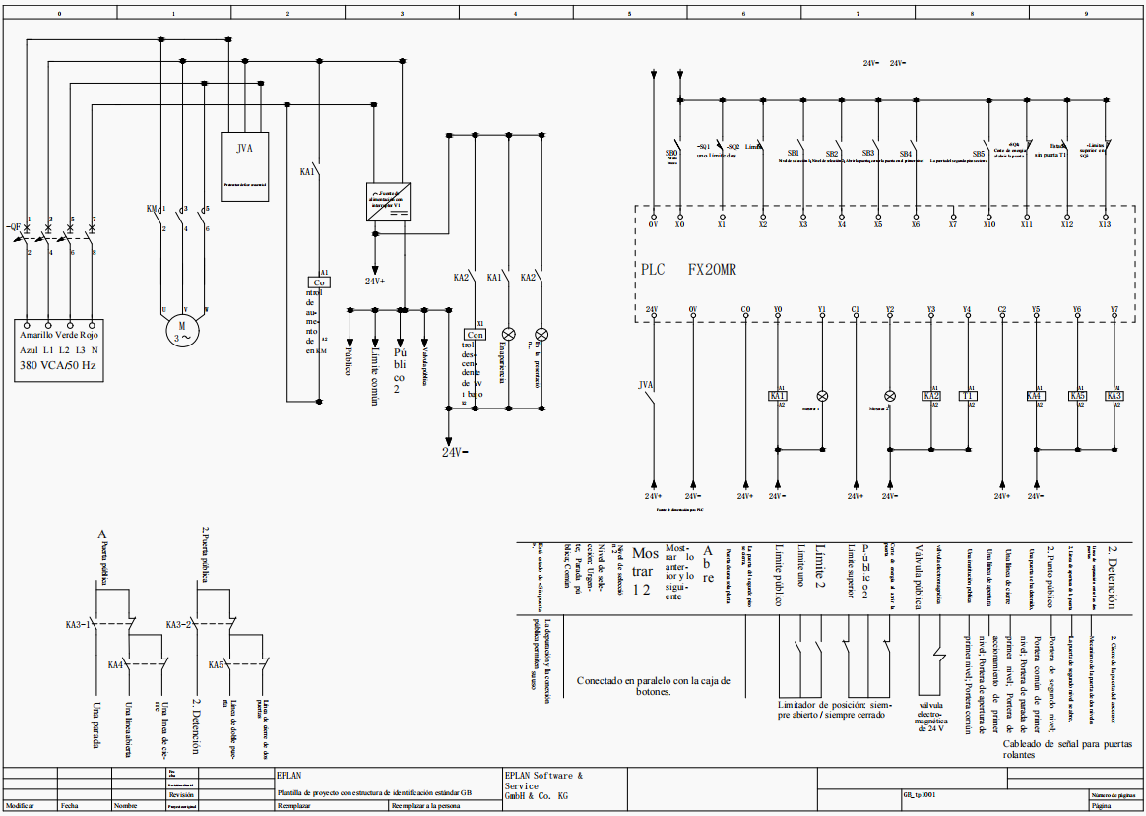

13. Installation of limit switches
Install the limit switch on the mounting plate and secure it with screws. Install the lower limit switch at the appropriate position on the bottom of the rail, tighten the screws on the mounting plate, and secure the upper limit switch using the same method.

14. Power-on lifting test
After the initial completion, power on the equipment to conduct a lifting test.
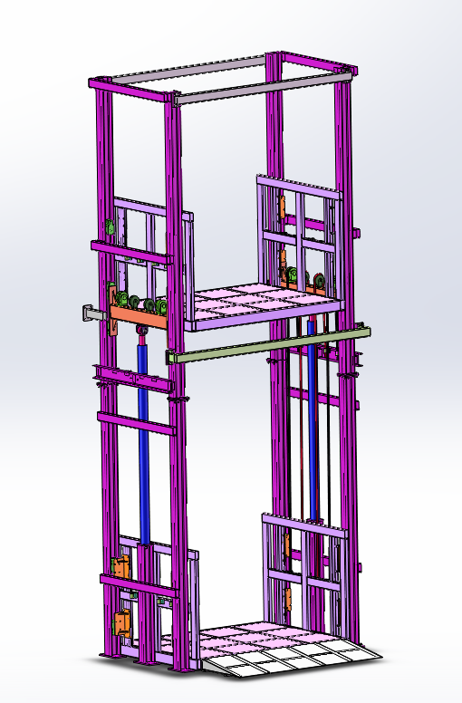
Figure 13: Overall schematic diagram of the device

IV. Post-Installation Inspection and Acceptance

(1) Static Inspection
- Check that all fasteners are tightened to the specified torque; the connections between the guide rail, bracket, and base seat must be secure and reliable, with no signs of loosening.
- Check the sealing integrity of hydraulic pipeline connections to ensure no oil or air leakage.
- Use a level and a steel feeler gauge to re-measure the straightness and parallelism of the guide rail, ensuring all precision parameters meet the equipment's technical requirements.

(II) Dynamic Trial Operation
- Manually or via pulse control, move the rail's moving component and observe whether the operation is smooth, without jamming, crawling, or abnormal noises.
- Operate under the rated load, monitor the stress and deformation of the guide rail, and confirm that the hydraulic system pressure remains stable with no abnormal vibration or noise.
- After running continuously for 2–3 cycles, monitor the hydraulic oil temperature rise to ensure it remains within the equipment's allowable range, and confirm that the cooling system is operating normally without overheating.

V. Maintenance and Care
- Clean the guide rail surface regularly to remove dust, cutting debris, and other contaminants, preventing scratches on the guide rail's working surface.
- Check the hydraulic oil level and quality monthly. If emulsification, deterioration, or impurities are detected, replace the hydraulic oil promptly and clean or replace the oil filter.
- Inspect the guide rail fasteners and hydraulic pipeline joints quarterly; reapply the specified torque to loose bolts and replace aged or damaged seals.

Contact
WhatsApp/Wechat: +86 13361054998
Email: sales@gradinlifts.com

